ROYAL AIR FORCE OFFICERS’ CLUB
JOHANNESBURG

www.rafoc.org
Po Box 69726
Bryanston
2021

Bank: NEDBANK
Melrose Arch
Code: 19 66 05
Account: 1966 278 063

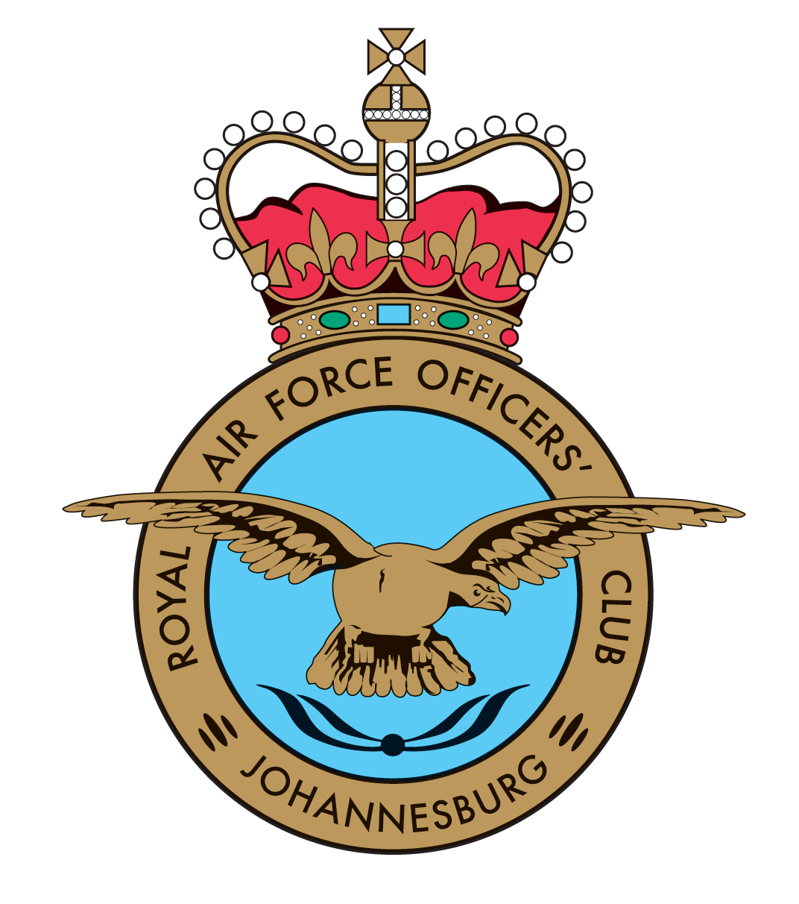 APPLICATION FOR MEMBERSHIP
Chairman: Bruce Harrison
083 325 0025 011 673 0291
bruce@jbharrison.co.za
Secretary: Colin Francis
082 853 8368 011 706 4554
cfrancis@vodamail.co.za
Treasurer: Jeff Earle
083 652 1002 011 616 3189
jeff@erbec.co.za
Personal Details:
Surname & Date of Birth:
First Names:
Nationality:
Contact Address:
Contact Numbers: Mobile / Land / Fax
E–mail Address: Spouse/Partner name:
In case of emergency – who should we contact?
Biographical Details: Brief details of your military career and/or personal interests in aviation.
-

Signature: Date:

I hereby apply to become a member of the Royal Air Force Officers’’ Club – Johannesburg, and if accepted I agree to abide by the Constitution and Rules of the Club which upholds the traditions and ethos of a Royal Air Force Officers Mess. I enclose my remittance (or proof of EFT) of R135 being the joining fee of R60 and first annual subscription of R75. The financial year is January to December.
I have known the applicant for (years) and vouch for the details and biography.
Proposed by
Signature

Date

Seconded by
Signature

Date
Committee Decision:
Accepted:
Declined:
Category: Ordinary
Associate
Affiliate
Applicant Notified: Yes – Date
Subscription Paid: Yes
No

Chairman:
Date:
Committee notes:

